Holcombe Hunt

By Graham L Taylor (1st October 2013)
I can remember that for several years after the 2nd World War (the late 1940’s) the Holcombe Hunt Point-to-Point races were held in the valleys between Ainsworth and Walshaw. The main entrance for the public spectators was through what is now a farm gate entrance on the right hand side of Arthur Lane, as you travel towards Harwood, on the double bend just after the Nurseries.
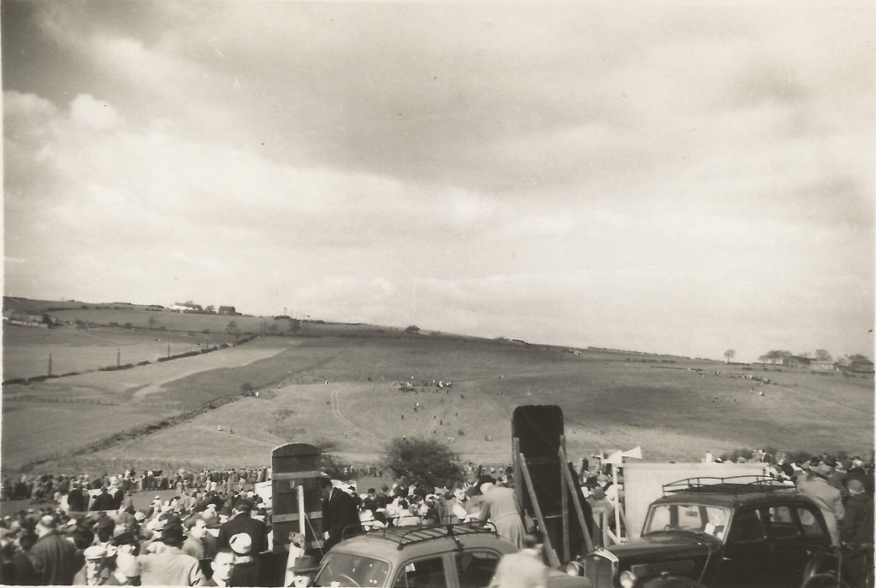On the occasion I attended the last race was at 4:30pm and the favourite won. At the same time as the race finished it started to rain and many of the bookies closed their cases and grabbed their blackboards and scampered off without paying out the winning punters
Ainsworth Village History Society

