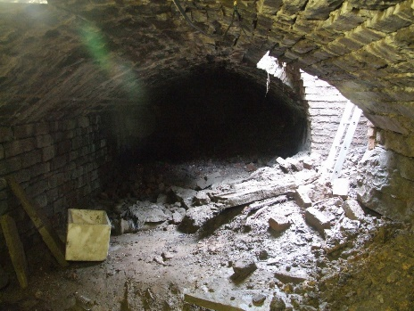
Ainsworth History Society www.ainsworthhistorysociety.org
We again meet on the Second Tuesday of each month from 7:30pm in the upstairs room of Ainsworth Church and Community Hall (on the corner of Bury Old Road and Ainsworth Hall Road). The next meeting is Tuesday 12th April. All are welcome.
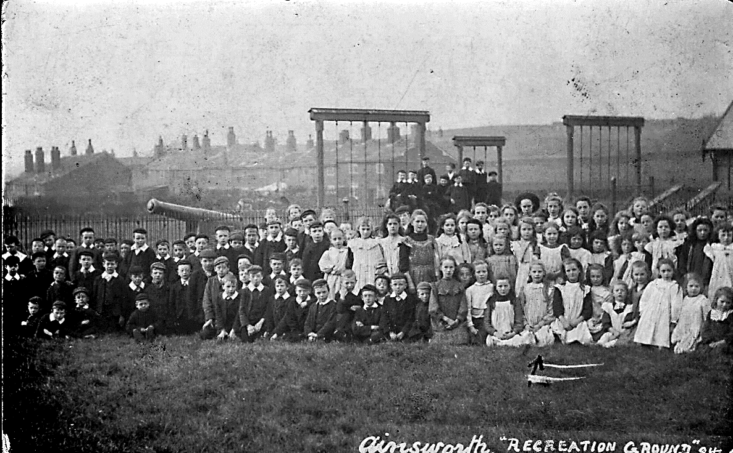
March Meeting:
We met in our new venue, which seemed to suit those present. We did a virtual walk along Bury Old Road and Church Street, from one end of the village to the other, interspersed with photos of what the buildings used to look like

